**Hand Book for Play Store Data product**

**By TONY JACOB**

# **Visualization Software**

**1.Power BI**

* Power BI is the software used in this Visualization product.
* To get started, go to the website <https://powerbi.microsoft.com/en-us/downloads/>

2. Install the Power BI application on your computer from the downloaded file.

# Data set Already Added

Dataset used for this visualization is the google play store applications data which is from the Kaggle website <https://www.kaggle.com/lava18/google-play-store-apps>

The data set can be loaded to the visualization using the get data tab on the toolbox.

For this visualization, the dataset already cleaned using the Microsoft Excel application and loaded to the PowerBI.

# Viewing the visualization product

For viewing the visualization, you have to open the Power BI file named “google_play_visualization” which is given along with this handbook.

# Visualization Data product

* The visualization data product contains two pages
* Page 1
* Page 2
* The first page contains the visualization mainly targeted to android application users
* This page has two user interactive variable which is price and category.

Select the price range for your application.

Select the category of the application you want to visualize

After giving these values to the data product.

Automatically visualize the graph and the other visualization tabs according to the given chosen data

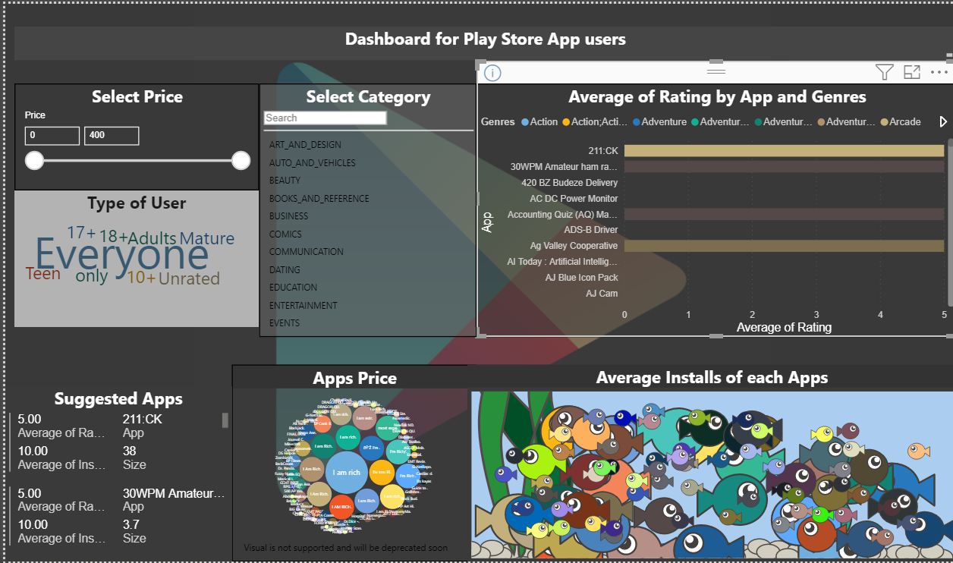

Moreover, an app suggestion box also placed at the left corner of page one which sorts the applications in the chosen category according to the average rating and shown with name and

Apps suggested for the users in the category they entered.

* The second page of the visualization product mainly targeted the app developer or the developing companies.
* Here there are two variables placed to interact with the product users the genre and the content rating
* A genre denotes the style of the application or can say an accurate category that the specific application belongs to.
* Content rating is the type of people the specific application targeted especially according to the age group
* These two variables will help the company or developer to study the change with these a build new apps according to their customers

The data product user can select the genre of the application

Data visualization product users can select the Content rating of the application to show the relationship between other variables

User interactive dashboard for app developers and app developing companies